**ASSIGNMENT SECTION 0**

Intel@DESKTOP-Q6Q0B5V MINGW64 ~

$ mkdir project_dir

Intel@DESKTOP-Q6Q0B5V MINGW64 ~

$ cd project_dir

Intel@DESKTOP-Q6Q0B5V MINGW64 ~/project_dir

$ git init

Initialized empty Git repository in C:/Users/Intel/project_dir/.git/

Intel@DESKTOP-Q6Q0B5V MINGW64 ~/project_dir (master)

$ touch index.html

Intel@DESKTOP-Q6Q0B5V MINGW64 ~/project_dir (master)

$ git status

On branch master

No commits yet

Untracked files:

(use "git add <file>..." to include in what will be committed)

index.html

nothing added to commit but untracked files present (use "git add" to track)

Intel@DESKTOP-Q6Q0B5V MINGW64 ~/project_dir (master)

$ git add index.html

Intel@DESKTOP-Q6Q0B5V MINGW64 ~/project_dir (master)

$ git commit -m index.html

[master (root-commit) e001fd4] index.html

1 file changed, 0 insertions(+), 0 deletions(-)

create mode 100644 index.html

Intel@DESKTOP-Q6Q0B5V MINGW64 ~/project_dir (master)

$ touch info.txt

Intel@DESKTOP-Q6Q0B5V MINGW64 ~/project_dir (master)

$ touch .gitignore

Intel@DESKTOP-Q6Q0B5V MINGW64 ~/project_dir (master)

$ git status

On branch master

Changes not staged for commit:

(use "git add <file>..." to update what will be committed)

(use "git restore <file>..." to discard changes in working directory)

modified: index.html

Untracked files:

(use "git add <file>..." to include in what will be committed)

.gitignore

no changes added to commit (use "git add" and/or "git commit -a")

Intel@DESKTOP-Q6Q0B5V MINGW64 ~/project_dir (master)

$ git add index.html

**1-**

**2-**

**3-**

**4-**

**5-**

**6-**

**7-**

**9-**

**10-**

**11-**

Intel@DESKTOP-Q6Q0B5V MINGW64 ~/project_dir (master)

$ git add index.html

Intel@DESKTOP-Q6Q0B5V MINGW64 ~/project_dir (master)

$ git commit -m 'commit insex.html file'

[master ede88ab] commit insex.html file

1 file changed, 5 insertions(+)

Intel@DESKTOP-Q6Q0B5V MINGW64 ~/project_dir (master)

$ git log

commit ede88ab440348131b162b65dab3aa3b0ec7fa9a1 (HEAD -> master)

Author: Shakshi Negi <shakshin4@gmail.com>

Date: Fri Jul 30 18:30:42 2021 +0530

commit insex.html file

commit e001fd41d5bbdef8a1c003ce160891c9f213a684

Author: Shakshi Negi <shakshin4@gmail.com>

Date: Fri Jul 30 18:23:52 2021 +0530

index.html

Intel@DESKTOP-Q6Q0B5V MINGW64 ~/project_dir (master)

$ git reset --hard

HEAD is now at ede88ab commit index.html file

Intel@DESKTOP-Q6Q0B5V MINGW64 ~/project_dir (master)

$ git add index.html

Intel@DESKTOP-Q6Q0B5V MINGW64 ~/project_dir (master)

$ git reset --hard

HEAD is now at ede88ab commit insex.html file

Intel@DESKTOP-Q6Q0B5V MINGW64 ~/project_dir (master)

$ git config --global alias.my-add add

Intel@DESKTOP-Q6Q0B5V MINGW64 ~/project_dir (master)

$ git my-add index.html

Intel@DESKTOP-Q6Q0B5V MINGW64 ~/project_dir (master)

$ git commit -m 'commiting the file'

On branch master

Untracked files:

(use "git add <file>..." to include in what will be committed)

info.txt

nothing added to commit but untracked files present (use "git add" to track)

Intel@DESKTOP-Q6Q0B5V MINGW64 ~/project_dir (master)

$ git revert ede88ab440348131b162b65dab3aa3b0ec7fa9a1

[master a006c96] Revert "commit index.html file"

1 file changed, 5 deletions(-)

**12-**

**14-**

**16-**

**17-**

**18-**

**19-**

**20-**

**SECTION 1**

**22 -**

Intel@DESKTOP-Q6Q0B5V MINGW64 ~

$ mkdir Assignments

Intel@DESKTOP-Q6Q0B5V MINGW64 ~

$ cd Assignments

**2 3-**

Intel@DESKTOP-Q6Q0B5V MINGW64 ~/Assignments (master)

$ git add README.txt

Intel@DESKTOP-Q6Q0B5V MINGW64 ~/Assignments (master)

$ git commit -m "Commit the README text file "

[master (root-commit) 2596665] Commit the README text file

1 file changed, 2 insertions(+)

create mode 100644 README.txt

Intel@DESKTOP-Q6Q0B5V MINGW64 ~/Assignments (master)

$ touch README.txt

**24-**

Intel@DESKTOP-Q6Q0B5V MINGW64 ~/Assignments (master)

$ git branch html-assignmets

**25-**

**26-**

Intel@DESKTOP-Q6Q0B5V MINGW64 ~/Assignments (master)

$ git branch html-assignmets

Intel@DESKTOP-Q6Q0B5V MINGW64 ~/Assignments (master)

$ git checkout html-assignmets

Switched to branch 'html-assignmets'

**28-**

**30-**

Intel@DESKTOP-Q6Q0B5V MINGW64 ~/Assignments (html-assignmets)

$ git add *.html

Intel@DESKTOP-Q6Q0B5V MINGW64 ~/Assignments (html-assignmets)

$ git commit -m "Commit html files"

[html-assignmets e5671c6] Commit html files

2 files changed, 26 insertions(+)

create mode 100644 one.html

create mode 100644 two.html

**31-**

Intel@DESKTOP-Q6Q0B5V MINGW64 ~/Assignments (html-assignmets)

$ git checkout master

Switched to branch 'master'

**33-**

Intel@DESKTOP-Q6Q0B5V MINGW64 ~/Assignments (master)

$ git checkout html-assignmets

Switched to branch 'html-assignmets'

**35-**

Intel@DESKTOP-Q6Q0B5V MINGW64 ~/Assignments (html-assignmets)

$ git add *.html

Intel@DESKTOP-Q6Q0B5V MINGW64 ~/Assignments (html-assignmets)

$ git commit -m "Commit html files"

[html-assignmets 2a99053] Commit html files

2 files changed, 2 insertions(+), 2 deletions(-)

**36-**

Intel@DESKTOP-Q6Q0B5V MINGW64 ~/Assignments (html-assignmets)

$ git checkout master

Switched to branch 'master'

**37-**

Intel@DESKTOP-Q6Q0B5V MINGW64 ~/Assignments (master)

$ git merge html-assignmets

Merge made by the 'recursive' strategy.

two.html | 13 +++++++++++++

2 files changed, 26 insertions(+)

create mode 100644 one.html

create mode 100644 two.html

**38-**

Intel@DESKTOP-Q6Q0B5V MINGW64 ~/Assignments (master)

$ git branch -d html-assignmets

Deleted branch html-assignmets (was 2a99053).

**SECTION 2-**

**1-**

Intel@DESKTOP-Q6Q0B5V MINGW64 ~/Assignments (master)

$ git branch css-assignments

Intel@DESKTOP-Q6Q0B5V MINGW64 ~/Assignments (master)

$ git checkout css-assignments

Switched to branch 'css-assignments'

Intel@DESKTOP-Q6Q0B5V MINGW64 ~/Assignments (css-assignments)

$ git add *.css

Intel@DESKTOP-Q6Q0B5V MINGW64 ~/Assignments (css-assignments)

$ git commit -m "add css files"

[css-assignments d89dfc5] add css files

2 files changed, 26 insertions(+)

create mode 100644 one.css

create mode 100644 two.css

Intel@DESKTOP-Q6Q0B5V MINGW64 ~/Assignments (css-assignments)

$ git add README.txt

Intel@DESKTOP-Q6Q0B5V MINGW64 ~/Assignments (css-assignments)

$ git commit -m "Commit README.txt file"

[css-assignments e7f9796] Commit README.txt file

1 file changed, 1 insertion(+), 1 deletion(-)

Intel@DESKTOP-Q6Q0B5V MINGW64 ~/Assignments (css-assignments)

$ git checkout master

Switched to branch 'master'

Intel@DESKTOP-Q6Q0B5V MINGW64 ~/Assignments (master)

$ git add README.txt

Intel@DESKTOP-Q6Q0B5V MINGW64 ~/Assignments (master)

$ git commit -m "Commit README.txt file third time"

[master 08391fb] Commit README.txt file third time

1 file changed, 1 insertion(+), 1 deletion(-)

Intel@DESKTOP-Q6Q0B5V MINGW64 ~/Assignments (css-assignments)

$ git commit -m "Commit css assignment file "

[css-assignments 659ef57] Commit css assignment file

2 files changed, 4 insertions(+), 2 deletions(-)

Intel@DESKTOP-Q6Q0B5V MINGW64 ~/Assignments (css-assignments)

$ git checkout master

Switched to branch 'master'

Intel@DESKTOP-Q6Q0B5V MINGW64 ~/Assignments (master)

$ git merge css-assignment

merge: css-assignment - not something we can merge

Intel@DESKTOP-Q6Q0B5V MINGW64 ~/Assignments (master)

$ git status

On branch master

nothing to commit, working tree clean

Intel@DESKTOP-Q6Q0B5V MINGW64 ~/Assignments (master)

$ git merge css-assignments

Auto-merging README.txt

Merge made by the 'recursive' strategy.

README.txt | 2 +-

one.css | 14 ++++++++++++++

two.css | 14 ++++++++++++++

3 files changed, 29 insertions(+), 1 deletion(-)

create mode 100644 one.css

create mode 100644 two.css

Intel@DESKTOP-Q6Q0B5V MINGW64 ~/Assignments (master)

$ git status

On branch master

nothing to commit, working tree clean

Intel@DESKTOP-Q6Q0B5V MINGW64 ~/Assignments (master)

$ git branch -d css-assignments

Deleted branch css-assignments (was 659ef57).

**2-**

**4-**

**6-**

**7-**

**8-**

**9-**

Intel@DESKTOP-Q6Q0B5V MINGW64 ~/Assignments (master)

$ git checkout css-assignments

Switched to branch 'css-assignments'

Intel@DESKTOP-Q6Q0B5V MINGW64 ~/Assignments (css-assignments)

$ git add *.css

Intel@DESKTOP-Q6Q0B5V MINGW64 ~/Assignments (css-assignments)

$ git commit -m "Commit css assignment file "

[css-assignments 659ef57] Commit css assignment file

2 files changed, 4 insertions(+), 2 deletions(-)

Intel@DESKTOP-Q6Q0B5V MINGW64 ~/Assignments (master)

$ git merge css-assignment

merge: css-assignment - not something we can merge

Intel@DESKTOP-Q6Q0B5V MINGW64 ~/Assignments (master)

$ git merge css-assignments

Auto-merging README.txt

Merge made by the 'recursive' strategy.

README.txt | 2 +-

one.css | 14 ++++++++++++++

two.css | 14 ++++++++++++++

3 files changed, 29 insertions(+), 1 deletion(-)

create mode 100644 one.css

create mode 100644 two.css

Intel@DESKTOP-Q6Q0B5V MINGW64 ~/Assignments (master)

$ git branch -d css-assignments

Deleted branch css-assignments (was 659ef57).

**10-**

**11-**

**12-**

**13-**

**14-**

**SECTION 3-**

**1-**

Intel@DESKTOP-Q6Q0B5V MINGW64 ~/Assignments (master)

$ git branch js-assignments

Intel@DESKTOP-Q6Q0B5V MINGW64 ~/Assignments (master)

$ git checkout js-assignments

Switched to branch 'js-assignments'

Intel@DESKTOP-Q6Q0B5V MINGW64 ~/Assignments (js-assignments)

$ git add *.js

Intel@DESKTOP-Q6Q0B5V MINGW64 ~/Assignments (js-assignments)

$ git commit -m "commit Javascript file"

[js-assignments 88077bc] commit Javascript file

2 files changed, 28 insertions(+)

create mode 100644 one.js

create mode 100644 two.js

Intel@DESKTOP-Q6Q0B5V MINGW64 ~/Assignments (js-assignments)

$ git add README.txt

Intel@DESKTOP-Q6Q0B5V MINGW64 ~/Assignments (js-assignments)

$ git status

On branch js-assignments

Changes to be committed:

(use "git restore --staged <file>..." to unstage)

modified: README.txt

Intel@DESKTOP-Q6Q0B5V MINGW64 ~/Assignments (js-assignments)

$ git commit -m "Commmit REadme.txt file"

[js-assignments 06e2a9c] Commmit REadme.txt file

1 file changed, 1 insertion(+)

Intel@DESKTOP-Q6Q0B5V MINGW64 ~/Assignments (js-assignments)

$ git checkout master

Switched to branch 'master'

Intel@DESKTOP-Q6Q0B5V MINGW64 ~/Assignments (master)

$ git add README.txt

Intel@DESKTOP-Q6Q0B5V MINGW64 ~/Assignments (master)

$ git commit -m "Commit README.txt"

[master f6aabef] Commit README.txt

1 file changed, 2 insertions(+)

**2-**

**3-**

**4-**

**5-**

**6-**

**7-**

**8-**

**9-**

Intel@DESKTOP-Q6Q0B5V MINGW64 ~/Assignments (master)

$ git checkout js-assignments

Switched to branch 'js-assignments'

Intel@DESKTOP-Q6Q0B5V MINGW64 ~/Assignments (js-assignments)

$ git add *.js

Intel@DESKTOP-Q6Q0B5V MINGW64 ~/Assignments (js-assignments)

$ git commit -m "commit javascript files"

[js-assignments 48b0e05] commit javascript files

2 files changed, 2 insertions(+)

Intel@DESKTOP-Q6Q0B5V MINGW64 ~/Assignments (js-assignments)

$ git checkout master

Switched to branch 'master'

Intel@DESKTOP-Q6Q0B5V MINGW64 ~/Assignments (master)

$ git merge js-assignments

Auto-merging README.txt

Merge made by the 'recursive' strategy.

README.txt | 2 +-

one.js | 14 ++++++++++++++

two.js | 14 ++++++++++++++

3 files changed, 29 insertions(+), 1 deletion(-)

create mode 100644 one.js

create mode 100644 two.js

Intel@DESKTOP-Q6Q0B5V MINGW64 ~/Assignments (master)

$ git branch -d js-assignments

Deleted branch js-assignments (was 48b0e05).

10-

11-

12-

13-

14-

**GIT REMOTING-**

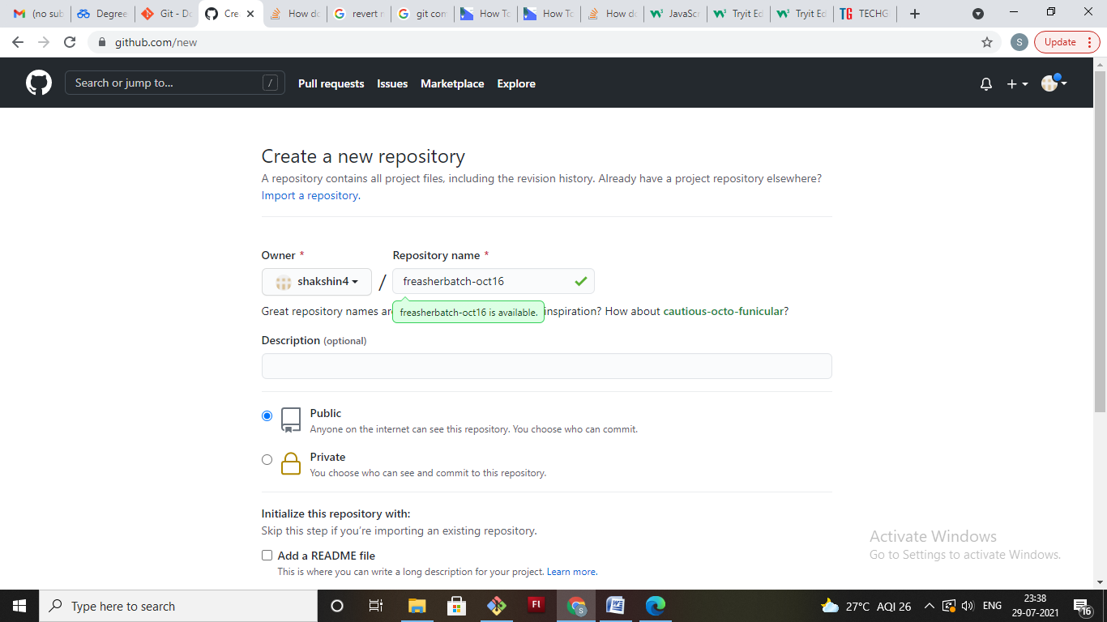

Intel@DESKTOP-Q6Q0B5V MINGW64 ~/Assignments (master)

$ git remote add origin 'https://github.com/shakshin4/freasherbatch-oct16.git'

Intel@DESKTOP-Q6Q0B5V MINGW64 ~/Assignments (master)

$ git push origin master

Enumerating objects: 51, done.

Counting objects: 100% (51/51), done.

Delta compression using up to 2 threads

Compressing objects: 100% (49/49), done.

Writing objects: 100% (51/51), 5.07 KiB | 54.00 KiB/s, done.

Total 51 (delta 20), reused 0 (delta 0), pack-reused 0

remote: Resolving deltas: 100% (20/20), done.

To https://github.com/shakshin4/freasherbatch-oct16.git

* [new branch] master -> master

**SECTION 4-**

